BikeScotland web pages activity
BikeScotland is a company with many stores throughout the country selling bikes. Customers are replacing their old bikes with more up-to-date ones or buying a bike for the first time. BikeScotland stocks racing bikes, mountain bikes and road bikes.

To try to obtain a greater share of the market, BikeScotland would like to have a website developed that will give details of their bestselling bikes. You have been asked to create sample web pages that will give BikeScotland some idea of what the final website would look like.

The design of the four web pages you have to create is shown below.

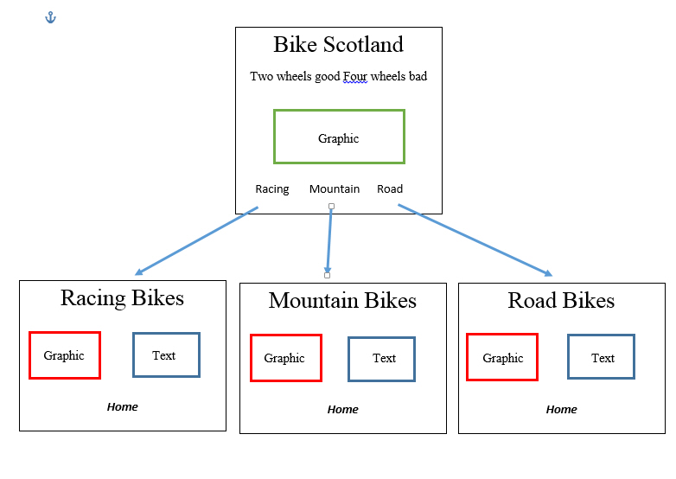
What you have to do
Your assessor will give you access to a web-authoring application and a copy of the graphics required for the web pages. You have to create the four sample website pages shown above.

Task 1
Using the files provided by your assessor, create the web pages ensuring that:

- the Home page is the opening page
- on all pages clicking on ‘Home’ will take the user to the Home page
- clicking on ‘Racing’ on the Home page will take the user to the Racing Bikes page
- clicking on ‘Mountain’ on the Home page will take the user to the Mountain Bikes page
- clicking on ‘Road’ on the Home page will take the user to the Road Bikes page

Task 2
Ask another candidate to use your website and see if it works the way it should.

Task 3
Describe one of the features and one of the functions of your web pages.

Task 4
- Name the software you used to create your webpages.
- Name the hardware you required to run the software.
- Name the storage capacity required for your website to run efficiently.

Task 5
Once the website has been completed, BikeScotland wants to publish it. They will need to upload the website to a web server so that it can be accessed by the public.

Describe one security risk that could affect BikeScotland’s website.

